**DAILY ONLINE ACTIVITIES SUMMARY**

|  |  |  |  |  |  |  |  |
| --- | --- | --- | --- | --- | --- | --- | --- |
| **Date:** | **7/06/2020** | | | | **Name:** | **Syed Rabeya Aamir** | |
| **Sem & Sec** | **8th B** | | | | **USN:** | **4AL16CS112** | |
| Online Test Summary | | | | | | | |
| **Subject** | |  | | | | | |
| **Max. Marks** | |  | | **Score** | |  | |
| Certification Course Summary | | | | | | | |
| **Course** | **Aws cloud practitioner essential** | | | | | | |
| **Certificate Provider** | | | **Aws** | **Duration** | | | **6 hrs** |
| Coding Challenges | | | | | | | |
| **Problem Statement:**  **1)** Python program to display the Fibonacci sequence. | | | | | | | |
| **Status: Solved** | | | | | | | |
| **Uploaded the report in Github** | | | | **YES** | | | |
| **If yes Repository name** | | | | **rabeya** | | | |
| **Uploaded the report in slack** | | | | **YES** | | | |

**Certification Course Details:**

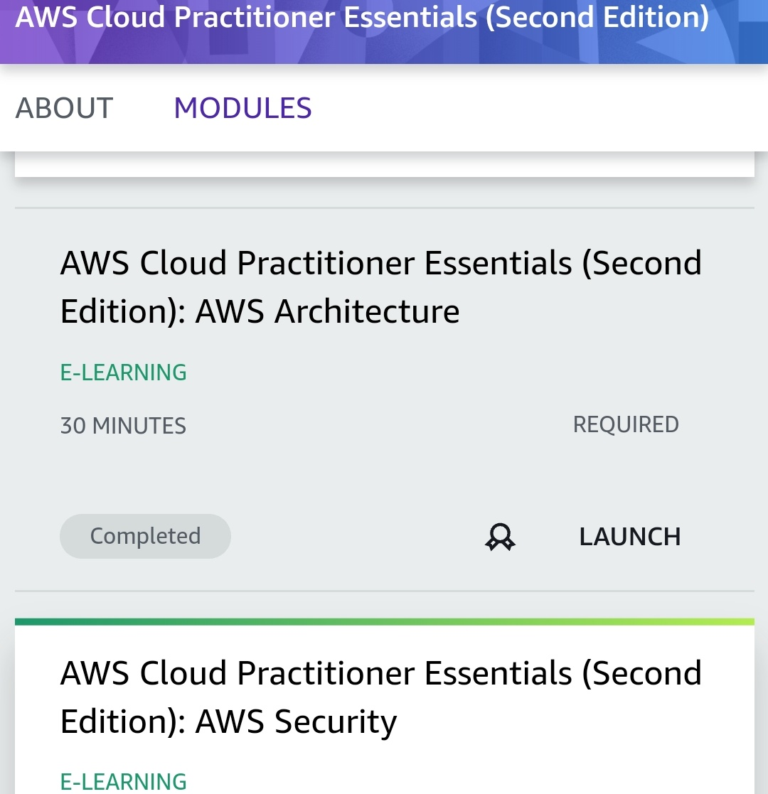

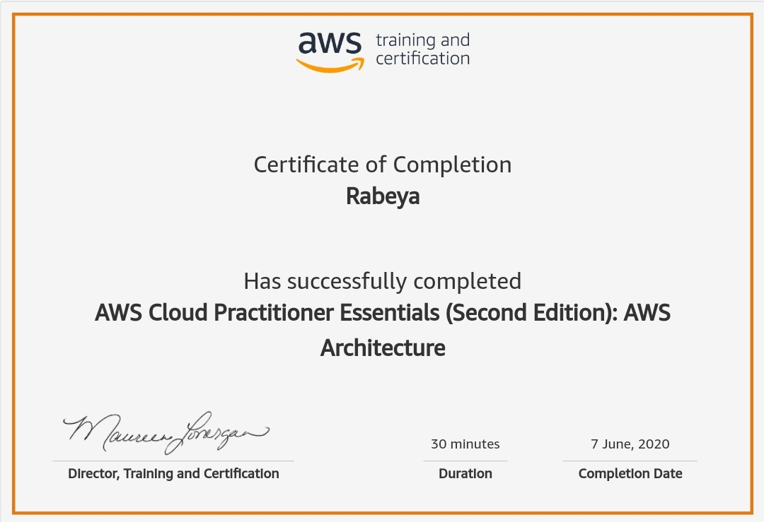

# CODE:

Program no:1

# Python program to display the Fibonacci sequence

def recur_fibo(n):

if n <= 1:

return n

else:

return(recur_fibo(n-1) + recur_fibo(n-2))

nterms = 10

if nterms <= 0:

print("Plese enter a positive integer")

else:

print("Fibonacci sequence:")

for i in range(nterms):

print(recur_fibo(i))